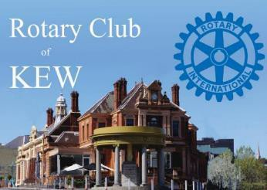

THE FOUR WAY TEST
Is it the truth?
Is it fair to all concerned?
Will it build goodwill and better friendships?
Will it benefit all concerned?
LINKS
Garden DesignFest Facebook Rotary D9800
www.rotaryclubofkew.org.au
President’s Message

Bulletin
RI District 9800
Volume 58 Number 41
May 8, 2025

Celebrating 57 Years of Service

Good afternoon everyone.
Today we welcome as our speaker, our own Margaret Turner-Atkins, who will talk to us about Neuropsychology, which promises to be very interesting.

On Saturday at the election we held a very successful sausage sizzle, which Margaret will tell you about. Many thanks to everyone who volunteered, and special thanks to a number of husbands who came along and helped.
In particular I must thank Barry Atkins whose ability to start a conversation with anyone, I think managed to sell a great many sausages!!!

As mentioned last week, we have been very noble and have changed the date of our Changeover Dinner to Thursday July 3rd, so it didn’t clash with North Balwyn’s Changeover. I know it inconveniences some people and I am very sorry about that.

I hope you have all searched your cupboards for antiques that you might want to sell, and have taken photos to send to Evelyne. I really appreciate this. I think we now have enough stall holders, which is a huge relief.

Please don’t forget about the art show at the Hawthorn Town Hall Gallery. Entry is free and the aboriginal artist is sponsored by Jill Forsyth at the shop. The notice is in the Bulletin.

Tomorrow week, Michael Stillwell, Colin Burns and I are off to the District Conference which is being held rather inconveniently, in Adelaide, so in a fortnight I should have some words of wisdom to impart to you all about the direction Rotary is going in District 9800.



PRESIDENT
Pam Norton
Ph 0409 667 552
p.j.norton28@gmail.com

SECRETARY
Alison Vickers
Ph 0402 431 590
alandmon@bigpond.net.au

MEETING
Kew Golf Club
120 Belford Road Kew East Thursday 12:30 pm
Meeting begins at 1pm

Apologies: Bob Crozier
bob_crozier@hotmail.com

Bulletin: Barb Brook
Barbbrook814@gmail.com

RI PRESIDENT
Stephanie A.Urchick

DISTRICT GOVERNOR

Michael Lapina
michael.lapina@rotary9800.org
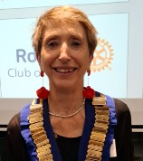

Dates for Your Diary
s
Saturday 10 May
2pm Official Opening Art display by the Namajerra people Hawthorn Town Hall Gallery entry free

Tuesday 13 May
5.30pm RCK Board Meeting – Colin’s

Thursday 15 May
1pm RCK meeting

16 – 18 May 2025
Morphettville SA Combined District Conference
Further details and bookings https://www.rotaryimpactsummit.org/about

Thursday 22 May
1pm RCK meeting - Fellowship

Thursday 29 May
1pm RCK meeting Speaker Kim Wen “Visit to China”

Thursday 5 June
1pm RCK meeting Speaker Prof Doug Brown AM “The Spice Islands”

Tuesday 10 June
5.30pm RCK Board Meeting

Thursday 12 June
1pm RCK meeting

Sunday 15 June
10am-4pm Antique Fair – Hawthorn Arts Centre

Thursday 19 June
1pm RCK meeting

Thursday 26 June
1pm RCK meeting

Thursday 3 July (please note change of date)
Rotary Club of Kew Changeover night

Saturday 5 July
District Changeover (lunchtime) more details to follow

Darwin

At the April Board Meeting we were delighted to accept
Jill’s Darwin project with the Larrikeet aboriginals.
The shop will continue to provide funding for Darwin.
Jill is excited that members of Kew Rotary would like to involve themselves with perhaps going to Darwin to assist and train in sewing etc. It would be a self funded trip in August. Please let Jill know if you are interested. There would be the opportunity for sightseeing during your time in Darwin.

Vale Graeme Sheahan

It is with great sadness I share with you that Graeme died last night. The funeral Service will be held at Le Pines East Kew on Friday 16 May, time to be confirmed.
There will be more in the Bulletin next week of Graeme’s wonderful contribution to Rotary. Our prayers and thoughts are with Jeanette and family at this sad time.

Art Exhibition

Lipwurrunga by Les Huddleston
The powerful life cycle of the Barramundi is at the heart of ‘Lipwurrunga’, a community exhibition showcasing Les Huddleston’s life and work. 30 April to 14 June, Hawthorn Town Hall Gallery, free entry
There will be finger food, and drinks at bar prices.
Image: Les Huddleston, detail from ‘Barramundi Together’ The official opening is Saturday 10 May

Event details
From the shimmering waters of the Roper River, the barramundi’s life unfolds—a dance of renewal and resilience, moving with the tides of nature and tradition. This powerful life cycle is at the heart of ‘Lipwurrunga’, a community exhibition showcasing Les Huddleston’s life and work, offering a vivid tribute to the landscapes, the wonders of nature and traditional stories of Arnhem Land, Northern Territory.
Through vibrant oil paintings, traditional wood carvings and didgeridoos, this exhibition connects ancient knowledge and practices with contemporary creativity and expression. Each work explores themes of sustainability, culture, and the deep and constant connection between people and Country.
Based in Melbourne for part of each year, the artist shares his art and wisdom with urban Aboriginal families, students and the broader Boroondara community, fostering understanding and unity. This exhibition is a celebration of tradition and a step forward in Australia’s reconciliation journey.

Toast to Rotary

The toast today was to Italy. There are 160 clubs in 13 districts.

Antique & Collectible Fair
June 15 Hawthorn Arts Centre

5 weeks away!

Plans are in place for an RCK table at the fair as outlined in last week's Meeting and Bulletin.

Gaie and Wendy have kindly agreed to take charge of this table- thank you ladies!

Please advise me if you have items for sale on your own behalf or with proceeds going to RCK.

We are not savvy about prices so please check on-line sources or with experts.

All items for sale must be marked with a swing tag with your first name & surname initial plus a fixed price for each item.

In addition, please provide a list in 3 columns on A4 paper--
Your name at top &/or to RCK
Item(short description or number of eg glasses | Price | Sold*

*Wendy or Gaie will enter Cash or C.Card after the sale of the item .
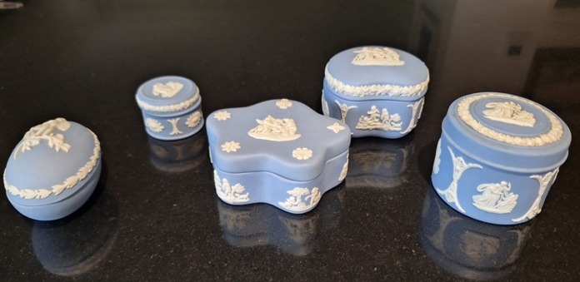
Money or receipt ( for credit card payment) from sales will be placed in a named envelope and sorted out afterwards.

All items must be on the RCK Table before the opening of the Fair and any unsold items must be collected at the end of sales
or they will be gifted to the OP shop.

Phone me on 0419 115971 or email me evelyneperks@netscape.net with any queries.
Many thanks
Evelyne Perks

Guest Speaker

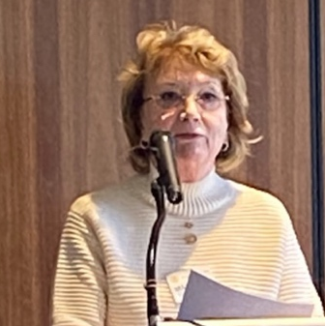
We were delighted to have Margaret Turner-Atkins as our speaker today. Margaret shared how when she finished school she wanted to go to Uni and was accepted into Health Sciences and also Primary Teaching. However, her parents were not in favour of this so she had to go out to work. She worked as a medical lab tech for 30 years. She then went to Uni and enrolled in Arts at La Trobe which included a psychology unit which she loved. She was then invited to study Behavioural Sciences and then do Honours. Margaret’s honours thesis was on Prospective Remembering (the ability to remember to perform a future action, often referred to as "remembering to remember") where she looked at older and younger people. Margaret then did a PhD at Melbourne Uni where she combined clinical and research work on Post Stroke Depression.
Margaret talked about the brain, its different parts and after injury you hope another part will take over although it will not be as good as the original. Margaret’s area of expertise is Neuropsychology a field that explores the relationship between brain function and behaviour, focusing on how brain injuries or illnesses affect cognitive and behavioural functions. Neuropsychologists use various tests and assessments to evaluate cognitive abilities and help diagnose and manage conditions affecting the brain. Margaret’s work is to provide strategies or rehab. We all took part in a memory test (15 words – how many did you remember). There is no right or wrong answer, just your own ability. Margaret is on the Board of the Stroke Association.and loves her work.

Thought of the Day

The thoughts were contributed by Joel
Ogden Nash’s Law
“Progress may have been all right once, but it went on too long.”
Bitton’s Postulate on State of the Art Electronics
“If you understand it , it is obsolete”

Rotary Golf

Good luck to Andrew and Russell who are taking part in this event tomorrow (Friday).

Election Day

Thank you Margaret, supported by Barry for all your work for the sausage sizzle last Saturday. Thank you also to all those who were part of the roster. There is $700+ profit.

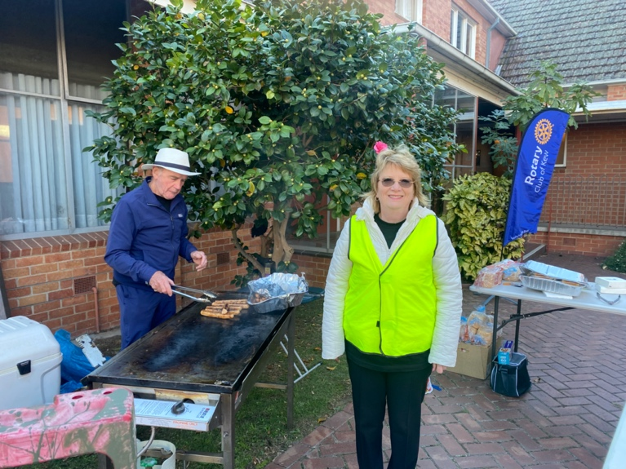

Almoner

Das continues to have regular contact with our members, and we thank him most sincerely for his continual care.

Raffle

The raffle this week was won by Margaret

Robert’s Idle Observations

I look sat people sometimes and think … Really? That’s the sperm that won.

Bulletin

Where possible, please submit information to barbbrook814@gmail.com by Wednesday for inclusion.

Bank Account Details

When making payments directly to the Club, please use the following details:
Bendigo Bank BSB 633-000
Account 125381590
Please remember to include your name and reason for payment in the reference

Antique & Collectible Fair
June 15 Hawthorn Arts Centre

5 weeks away

Other Rotary Clubs

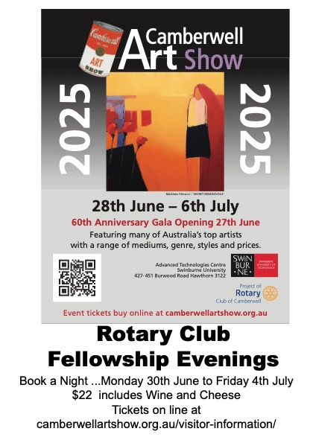

The Rotary Club of Kew acknowledges the ongoing support of the following businesses

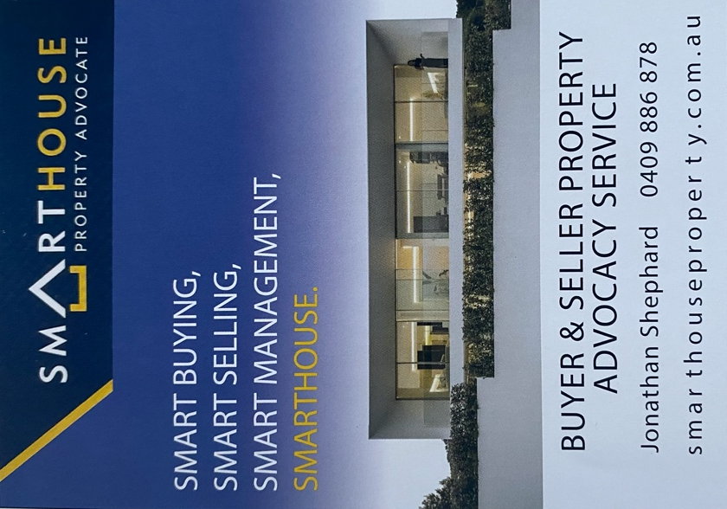

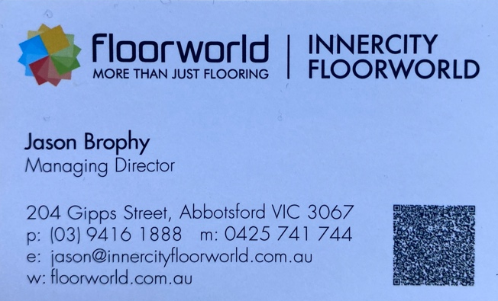

Meeting Duty Roster

Date | Chair | Host | Meeting Equipment | Cashier-1 | Cashier-2 | Thought
15-May | Levin R | Devidas D | Hoath R | Wen K | Garling W | Wen K
22-May | Ewart C | Brown D | Cohen J | Dadafarin M | Verginis G | Verginis G
29-May | Stillwell M | Cohen J | Dalziel A | Payne F | Stewart P | Ibbotson P
05-Jun | McFarlane M | Dadafarin M | Payne F | Vickers A | Turner-Atkins M | Perks E
12-Jun | Crawford J | Scott J | Devidas D | Levin R | Stillwell M | Bourke M
19-Jun | Stewart P | Ibbotson P | Crozier B | Dias C | Perks E | Brown D

